Mirano-Venice, January 8th, 2010

To All Members of the ITF Taekwon-Do

Dear Master/Instructor,

We are proud to inform you that ‘Jolly Fitness’ Sports Club together with Veneto Taekwon-Do Committee is organizing the:

VI° Veneto Open Championship of Taekwon-Do I.T.F.

The competition will be held at the gymnasium of Campocroce of Mirano (VENICE - ITALY) in Via Jacopo Mogno (map) on Sunday, 21th of march, 2010.

Hoping in your presence at this Event, sincerely Yours in Taekwon-Do.

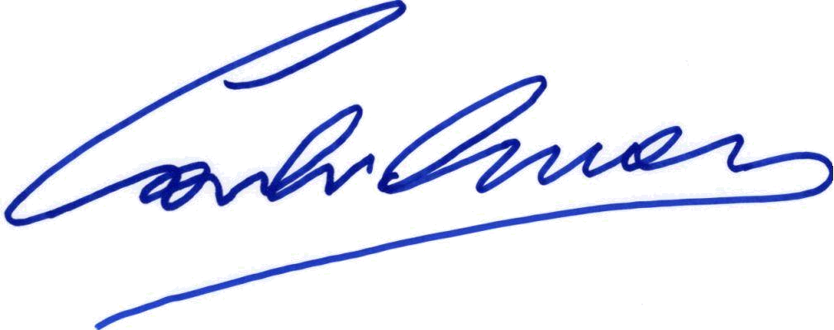  Veneto Taekwon-Do Committee Secretary and TKD Mirano President  Mr. Omar Carli |  | 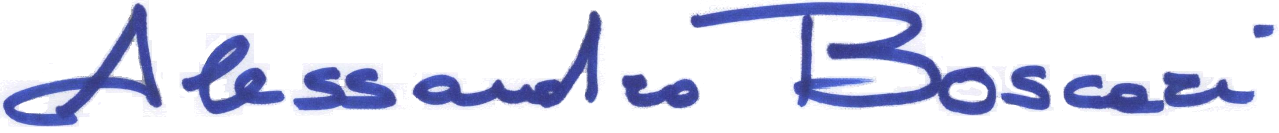  Veneto Taekwon-Do Committee President  Mr. Alessandro Boscari

 | Competitors entrance fee
Enrolment cost is 20,00 € for each competitor.

Registration
Registration deadline is: March 5th, 2010
Please send your registration form to open.veneto@gmail.com

For hotel reservations please make reference directly to the contact list below:

Mirano’s Hotel
B&B in Mirano

Championship Schedule

Date 21th March, 2010
Place Campocroce of Mirano (Venice- ITALY)
Address Gym, via Jacopo Mogno

Sunday, March 21th, 2010
Competitors check-in 8.00 a.m. - 09.00 a.m. (weigh in)
Umpires / Coaches Meeting 08.00 a.m. – 09.00 a.m.
Competition 9.00 a.m. – 12.30 p.m.
Lunch break 12.30 p.m. – 13.30 p.m.
Competition 13.30 p.m. – at the end

Patterns competition
Categories will be organized as follows:

Section E yellow belt
Section D green belt
Section C blue belt
Section B red belt
Section A-I black belt I degree
Section A-II black belt II degree
Section A-III black belt III degree
Section A-IV black belt IV, V and VI degree

Pattern competition schedule:
Sections B, C, D and E Preliminary matches & finals One free pattern
Score by flags
Section A Preliminary matches One free pattern
Score by flags
Semi-finals & finals - One free pattern
- One pattern designated
Score by cards

Sparring competition
Sparring Classes:
Section C yellow and green belt
Section B blue and red belt
Section A black belt

Sparring Weight category:
Juniores male -55 kg -62 kg -70 kg +70 kg
Juniores female -45 kg -52 kg -60 kg +60 kg
Seniores male -54 kg -63 kg -71 kg -80 kg +80 kg
Seniores female -50 kg -57 kg -65 kg +65 kg

Sparring competition schedule:
Section C Preliminary matches & finals One round of two minutes (Light-contact)
Section B Preliminary matches & finals One round of two minutes (Light-contact)
Section A Preliminary matches One round of three minutes (Light-contact)
Semi-finals & finals Two rounds of two minutes

Apparel and sparring protections
Compulsory | Optional
Official ITF Dobok and belt  Head guard (for all competitors)  Sparring gloves  Sparring boots  Groin guard (male) | Teeth protection  Shinbones Protections  Breast Protection (female)

Registrations and weight check
Registrations and weight check in will take place at the gym, on Sunday, March 21th, 2010 from 8.00 a.m. to 09.00 a.m. and during the patterns competition.

Entrance fees should be settled only by the team leader.

Is possible to make the payment only via

CARLI OMAR
IBAN CODE: IT 91 E 02008 62170 000040142330
SWIFT CODE: UNCRITB1A82

All competitors weight will be checked except for heavyweight.

Competitors out of weight category:
- will be excluded from the competition or
- will have to pay a fine of 20,00 € to continue competition in the right category (if not already completed).

Competition matches list will be displayed at gym on Sunday, March 21th, 2010 from 8.00 a.m.

Umpires
F.I.TAE./I.T.F. rules will be applied; any change will be communicated during the umpires meeting on Sunday, March 21th, 2010.
All Clubs must provide at least one umpire (I degree or upper). If no umpire will be provided by the Club there will be a penalty of 20,00 € for each competitor.
We’ll be grateful to the Clubs that will provide more than one referee. This will allow the competition to be easier and faster.

The Organization Committee will provide Sunday lunch for referees who will ensure the presence for the full competition.

Coaches
Coaches have to wear sports tracksuit and shoes.

Protests
The participation to the competition implies the complete acceptance of the regulations.
During the “Open Veneto Championship” no protests will be accepted.

How to get to Campocroce di Mirano

By car arriving from the A4:

Driving directions to Via Jacopo Mogno, 30035 Mirano VE
9,8 km – about 14 min - 9.8 kilometers

1.1. Procedi in direzione est da A4 verso Passante di Mestre Proceed in an easterly direction from the Mestre A4 Strada a pedaggio 0,6 km 0.6 kilometers
2.2. Prendi l'uscita Dolo-Mirano verso Dolo/Mirano Take the exit Dolo-Mirano to Dolo / Mirano Strada a pedaggio parziale1,3 km1.3 kilometers
3.3. Alla rotonda, prendi l'uscita 2a verso Dolo/SP26/Mirano At the roundabout take the 2nd exit towards Dolo/SP26/Mirano 1,0 km1.0 kilometers
4.4. Svolta a destra in SP26/Via Stazione Turn right SP26/Via Stazione Continua a seguire la Via Stazione1,1 km1.1 kilometers
5.5. Svolta leggermente a sinistra in Via Ballò Slight left at Via Ballò 0,7 km0.7 kilometers 6.
6. Continua su Via Volpin Continue on Via Volpin 1,0 km1.0 kilometers 7.
7. Svolta a destra in Via Accopè/SP34 Turn right onto Via Accopè/SP34 - Continua a seguire la SP34Continue to follow the SP34 2,8 km 2.8 kilometers
8.8. Svolta a sinistra in Via Braguolo Turn left onto Via Braguolo 0,7 km0.7 kilometers 9.
9. Prendi la 1a a destra in corrispondenza di Via Chiesa Campo Croce Take 1st right at Via Chiesa Campo Croce 0,5 km0.5 kilometers
10.10. Take the 1st left at Via Jacopo Mogno

For further information, check the following web sites:

http://www.viamichelin.com
http://www.maps.google.com

By plane from Treviso Airport:

Driving directions to Via Jacopo Mogno, 30035 Mirano VE
28,1 km – about 35 min - 28.1 kilometers

1.1. Procedi in direzione est su Via Noalese Proceed east on Via Noalese 78 m78 m
2.2. Prendi la 1a a sinistra per rimanere su Via Noalese Take the 1st left to stay on Via Noalese 87 m87 m
3.3. Svolta a sinistra in Via Noalese/SR515 Turn left onto Via Noalese/SR515
Continua a seguire la SR515 Continue to follow SR515 - Attraversa 1 rotondaGo through 1 roundabout 13,5 km13.5 kilometers
4.4. Svolta a sinistra in Via Roma/SR515 Turn left onto Via Roma/SR515 Continua a seguire la SR515Continue to follow SR515 11,2 km11.2 kilometers 5.
5. Svolta a sinistra in Via Cavin di Sala/SP32 Turn left onto Via Cavin di Sala/SP32 Attraversa 1 rotonda Go through 1 roundabout 2,1 km2.1 kilometers
6.6. Svolta a destra in Via Chiesa Campo Croce Turn right onto Via Chiesa Campo Croce 0,9 km0.9 kilometers 7.
7. Svolta a destra in Via Jacopo Mogno Turn right into Via Jacopo Mogno

From Marco Polo Airport:

Indicazioni stradali per Via Jacopo Mogno, 30035 Mirano VE Driving directions to Via Jacopo Mogno, 30035 Mirano VE
30,2 km – about 37 min - 30.2 kilometers

1.1. Procedi in direzione sudest verso Via Giovanni Bonmartini Proceed towards the southeast towards Via Giovanni Bonmartini 1,2 km1.2 kilometers
2.2. Prosegui dritto su Via Giovanni Bonmartini Continue straight onto Via Giovanni Bonmartini 0,3 km0.3 kilometers
3.3. Svolta a destra in Viale Alvise Ca' da Mosto Turn right onto Viale Alvise Ca 'da Mosto 0,1 km0.1 kilometers 4.
4. Svolta a sinistra in SS14/Via Triestina Turn left SS14/Via Triestina 0,6 km0.6 kilometers
5.5. Continua su A27 Continue on A27 5,0 km5.0 kilometers
6.6. Prendi l'uscita per A4/E70 verso Venezia/Milano/A13/Padova/Bologna Take the exit for A4/E70 to Venezia/Milano/A13/Padova/Bologna 7,6 km7.6 kilometers
7.7. Prendi l'uscita verso Mestre/Via Miranese/SP32/Mirano Take the exit toward Mestre / Via Miranese/SP32/Mirano 0,5 km0.5 kilometers
8.8. Alla rotonda, prendi l'uscita 2a verso A4/Milano/Venezia At the roundabout take the 2nd exit towards A4/Milano/Venezia 0,4 km0.4 kilometers
9.9. Turn right onto Via Miranese Attraversa 1 rotondaGo through 1 roundabout 2,3 km2.3 kilometers
10.10. Prosegui dritto su Piazza San Giorgio Continue straight onto Piazza San Giorgio 0,1 km0.1 kilometers
11.11. Continua su Via Miranese Continue on Via Miranese 0,5 km0.5 kilometers
12.12. Continua su Via Roma/SP32 Continue on Via Roma/SP32
Continua a seguire la SP32 Continue to follow the SP32 Attraversa 3 rotondeGo through 3 roundabouts 10,5 km10.5 kilometers
13.13. Svolta a sinistra in Via Chiesa Campo Croce Turn left onto Via Chiesa Campo Croce 0,9 km0.9 kilometers
14.14. Svolta a destra in Via Jacopo Mogno Turn right into Via Jacopo Mogno

 | Competition Organization Committee
Mr. Alessandro Boscari |  | Italian Umpires Committee Chairman  Veneto Taekwon-Do Committee President | Championship Umpires Committee Chairman
Mr. Andrea Canteri |  | F.I.TAE Competitions Chairman | Competition Chairman
Mr. Omar Carli |  | Veneto Taekwon-Do Committee Secretary | Competition Committee Member and Jolly Fitness Sports Club President

The Championship Organization declines every responsibility on eventual damages to things or persons also coming from lack of the necessary medical controls of competitors.

