
6 ^{rd} Open Taekwon-do Friendship Cup Of European Nationalities

Date: Saturday Apr 26 2008
Place: Kodály Zoltán School Sports hall, Hatvan (map enclosed)
Géza fejedelem út 1
Organizer: Hatvani Taekwon-do Club
Head referee: Mr. László Harmat 7. Dan

Start fees: 20.00 Euro, the competitor would participate at sparring and patterns

Weighing: Friday 17.00-20.00 p.m.
Saturday 7.30-8.30 a.m.

Referees: The hungarian and international critical mixed. Every club must provide 1 (one) referee. If you don’t have a referee, you must pay 30 Euro. The organiser provides the referees with lunch on Saturday. Referees's clothing: white skirt, dark tie, black trousers, white shoes.

Entry divisions: Girls and boys up to 8 years and minimum 8 gup (yellow belt)
One competitor would entry just one category!

Age classes:
Youth: Up to the age of 14 if not exceeded on the day of the Competition
Junior: Up to the age of 18 if not exceeded on the day of the Competition

Patterns: Youth and Junior boys and girls
8 gup Dan-gun tull
6 gup Won-hyo tull
4 gup Joon-gun tull
2 gup Hwa-rang tull
1 dan Kwang-gae tull

Weigh Categories: Youth boys:
-30, -35, -40, -45, -50, -55, +55 kg
Youth girls:
-30, -35, -40, -45, -50, + 50 kg
Junior boys:
-52, -58, -63, -71, + 71 kg
Junior girls:
-48, -53, -58, -63, + 63 kg
Sparring Duration: Youth 1x2 minutes, Finals: 2x1,5 minutes
Junior 1x2 minutes, Finals: 2x1,5 minutes

Safety Equipment: Hand and feet protective equipment, boys have to wear
toque under the dobok.. Permitted are: mouthprotector,
chestprotector only for women, Shin protector

Prizes: Cups will be awarding for a Ist-IInd-IIIrd place (for the third place
sparring is required) + certification + surprise award

Program:

May 05 (Saturday)
7.30 – 8.30 Weighing
8.30 – 9.00 Technological meeting
9.00 Opening ceremony
Patterns eliminating and finals
11.00 Sparring eleminating
13.00 – 13.30 Lunch-time
13.30 – 18.30 Eliminating and finals
18.30 – 19.00 Prize-giving, competiton closing

Information of accomodation in english Gabor Józsa +3620/515-1721

Final date of application: 20 ^{th} of April 2008

If you are changing your competitor’s weight group in the field you must pay 5 Euro

Information and address, e-mail: woomyo@freemail.hu
www.taekwondo60.hu
Fax: 00-36-37/344-649

Hatvan, 14. Marc 2008.
Yours sincerely,

Ferenc Hatvani
IV.Dan
Club leader
Application form
youth 8-14 years

Name of Club: ________________________________________________________________
Address: ________________________________________________________________
Contact person: ________________________________________________________________
Phone: _______________________
Fax: _________________________
E-mail:_______________________
Coach: ________________________________________________________________
Umpire: ________________________________________________________________

No Name and Surname Sex Date of birth Grade Weight Tul Sparr.

Application form
junior 14-18 years

Name of Club: ________________________________________________________________
Address: ________________________________________________________________
Contact person: ________________________________________________________________
Phone: _______________________
Fax: _________________________
E-mail:_______________________
Coach: ________________________________________________________________
Umpire: ________________________________________________________________

No Name and Surname Sex Date of birth Grade Weight Tul Sparr.

Maps if you travel by car/bus:

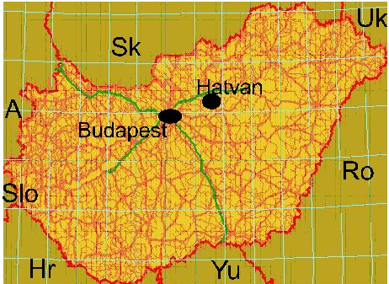

City of Hatvan is approx. 55 kms from Budapest on the M3 highway or No. 30 main road. Note: Highways in Hungary are payable. You can buy a weekly ticket at the border stations, valid for M1, M3 and M7 highways.
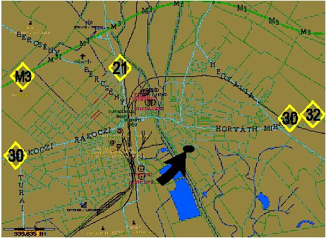

There will be direction boards int he city for your help.

